Title of the paper, being prepared in MS Word for Windows (max. 80 characters)

J. Br. Papic & I. Peshevski

Universtity Ss. Cyruil and Methodius, City, Country

[post@eurock.com](mailto:post@eurock.com) (email of corresponding author)

E. Angelova

Geohydroconsutling, City, Country

Abstract

This is where you write the abstract. Please do not use more than 300 words. No references should be used in the abstract. If appropriate, split the abstract in background, methods, results and conclusion. Start each segment with a new paragraph, but do not use headlines.

Please give a precise and descriptive title of the paper that do not span over 80 characters. Please do not use tittles for the authors (e.g. MSc, PhD, Prof). Give one email address for correspondence. For text formatting of the paper use the styles provided in the template. Section one of the paper starts on top of page two.

The papers will be published digitally only. For conference attendees they will be available at memory sticks provided at the conference. The papers will be available for all ISRM members at the One Petro homepage, onepetro.org, after the conference.

ISRM Regional Symposium – EUROCK 2026. The event will take place in the Aleksandar Palace Hotel, in the beautiful city of Skopje from September 15th to 19th 2026.

The historical city of Skopje is the country's capital. A Roman military camp was founded here in the second century BC on the site of an older Dardanian settlement. It became later Colonia Flavia Aelia Scupi. A Roman town was founded in the time of Domitian (AD 81–96). Today it is the country’s political, cultural, economic, and academic centre.

Keywords

Authors guide, Eurock 2026, Rock Engineering, Skopje (max 5 keywords)

# Introduction

## Text

The maximum length of the paper is eight pages, including tittle page, figures and references. The body text is Times New Roman 11 pt. Headings are Garamond, bold, size 15, 13 and 11 pt. Use the predefined styles. Do not adjust the page margins. For the body text use the Normal style. Words can be emphasized using italics.

## Headings

If a sub heading is used, one must have two or more sections/chapters of the same level. As in this case, if there is a section 1.1, one must also have a section 1.2.

### Third level heading

There should not be used more than three levels of headings. And, as for level 2 headings, one must have at least two level three headings.

### A second third level heading

This is a second third level heading to allow the one above.

# Figures, tables and equations

All figures and tables are too be referred to in the text in consecutive numerical order. Tables are named “Table” and figures “Fig.”.

For captions on tables and figures use the “Insert caption” option in the “References” tab. When referring to tables, figures and sections, use the “Cross-reference” option in the “References” tab. For help search the phrase “insert caption word” or click [here](https://support.office.com/en-us/article/add-format-or-delete-captions-in-word-82fa82a4-f0f3-438f-a422-34bb5cef9c81). Using this option captions are automatically formatted using the “Caption” style.

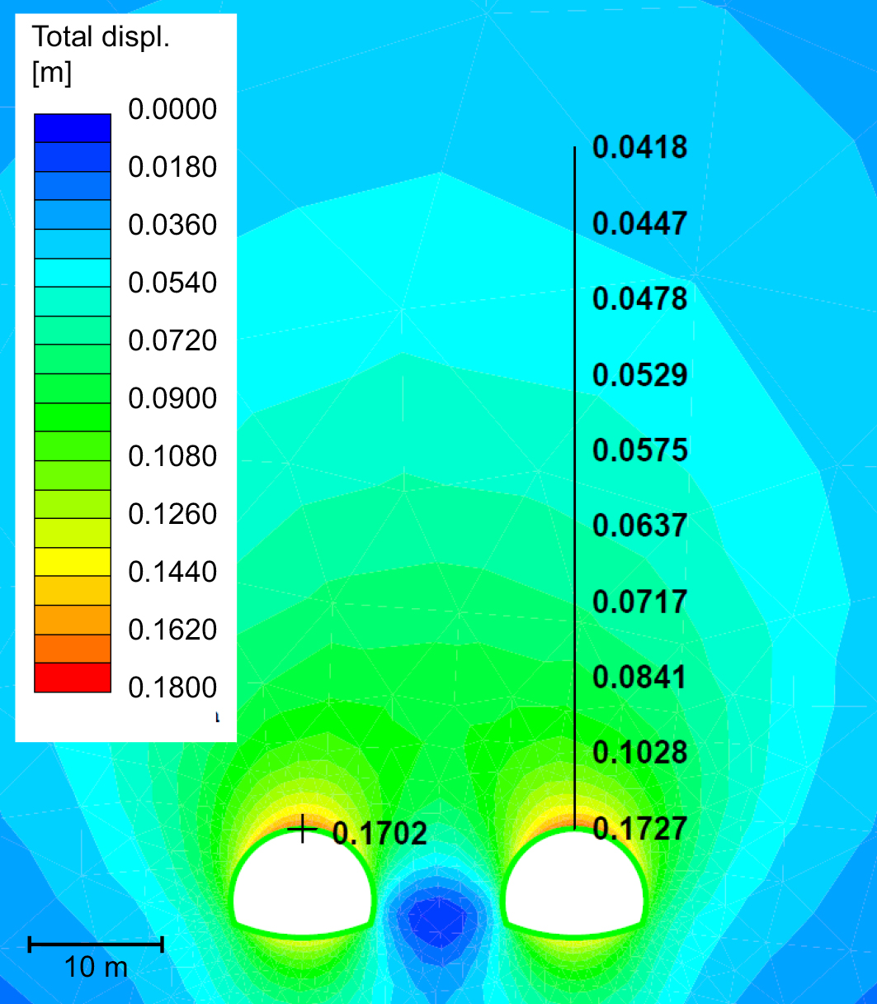

Fig. 1 Figures must be referred to in the text. Try to place the figures close to were they are referred to in the text.

Figures are to be formatted with a width of 8, 12 or 16 cm. Widths for figures that are higher than they are wide, should as a main rule be 8 or 12 cm wide. Minimum pixel resolution is given in and corresponds to a resolution of 250 dpi. For text in the figures use the font “Arial”, and the size should not be smaller than 8 pt on the figure placed in the paper (see ). The different parts of the figure can be named with e.g. a) and b) and referred to in the caption and/or the text.

The figures are to be inserted as a jpg-file. Excel diagrams and illustrations made in Power Point must be made into a picture file before placed in the document. To avoid a gap between the figure and caption, the figure must be formatted with the “No Spacing” style, by first select the figure and then select the No spacing style.When appropriate, remember to use scales, name axis and specify units in the figures.

## Instructions on table formatting

To create a table use e.g. the table option in the “Insert” tab. After creating the table, select it and choose the “Table” style. Tables are to have borders as shown in Table 1, a horizontal line above and below the top row, and below the last row.

For the main text inside the table use font style “Table”. For the top row use “Table top row”.

Table 1 Minimum horizontal pixel resolution on figures

|  |  |
| --- | --- |
| Figure width [cm] | Horizontal numb. of pixels |
| 8 | 800 |
| 12 | 1200 |
| 16 | 1600 |

## Equations

To position equations a table with two columns and no borders are used. Place table as explained before and apply the “Table” style. For the equation use the “No spacing” style. The equation is placed in the middle cell and the equation number is placed in the far right. Equations are numbered in consecutive numerical order with parenthesis on each side and aligned “Align centre right” in the Table tools – Layout tab. When referring to equations use “Eq.”. Explain symbols as they appear, and only once. See Eq. 1.

|  |  |
| --- | --- |
| $$τ=\frac{f}{πd_{b}(L-s)}$$ | (1) |

Where *τ* Mean bond shear strength

*f* Applied load

*L* Embedment length

*s* Bolt displacement

*db* Bolt diameter

# How to cite references

In the text one cites references as follows: (Author 2011), (Author1 and Author2 1999) or (Author1 et al. 2014). Multiple references are separated by semicolon (Author1 2014; Author2 and Author 3 2017). References can also be sited in the text like Author1 (1997) and Author1 et al. (2013).

A reference list showing all sited references is included at the end. For formatting see the references list at the end.

References

Author1 NN, Author2 F (2011) The title of the journal paper may be quite long and make the reference span many lines. JournalNameJournalVolume (Issue): pages. DOI.

Author1 NN, Author2 F (2013) The title of the conference paper may be quite long and make the reference span many lines, even longer than this. ConferenceName, ConferenceLocation, CoferenceDate

Author1 NN, Author2 F (2014) Titles of books are normally short. 3rd edn. Publisher, Location

Author1 NN, Author2 F (2015) A report reference should look like this. ReportSeriesName. Institution, Location

Author1 NN (2016) This is a dissertation reference. Dissertation at UniversityName

Author1 NN, Author2 F (2016) An online reference title. <http://where.it/was/found>. Accessed at Accessed Date