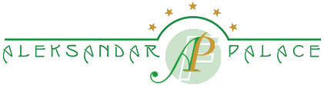

HOTEL ALEKSANDAR PALACE

8-mi Septemvri No. 15, 1000 Skopje, Macedonia

RESERVATION FORM


Name:______________________________ Surname: ______________________________

Please book on my behalf 1 room for the period of _________ → _________ number of nights ____.

I would like to book:

Single Room At the special rate of 100 EUR per room/night

Double Room At the special rate of 125 EUR per room/night

Room rates include Buffet Breakfast and local taxes (VAT 5% and all other applicable taxes).

Method of guarantee and advance Payment

Credit Card, type: _______________ No.____________________________ Exp. Date_____________

Card holder signature: __________________________

Or

Deposit in Advance: please contact the hotel for advance payment by bank transfer.

The above mentioned rates are valid only for this group during 15th -19th of September, 2026. The reservations will be accepted on a space availability basis. All reservations wil1 be held on a credit card guaranteed arrival basis.

Any guest room reservations confirmed and guaranteed through the Reservation Form,7 days before arrival not claimed on the day of arrival (no show), will be canceled and the credit card will be charged with 100% penalty for the entire length of stay.

Thank you for booking with us!
Tel.: +389 2 3092 392, Fax: +389 2 3092 262
info@aleksandarpalace.com.mk

